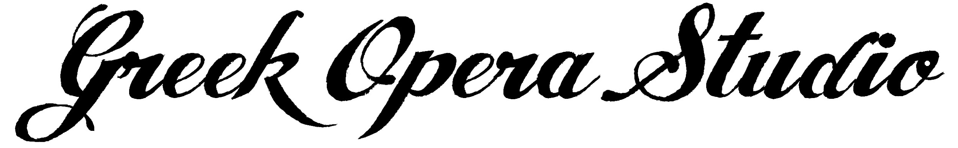

Greece
July 9-28, 2025
AUDITION APPLICATION

Please fill out this information form and return it to Eilana Lappalainen, GreekOperaStudio@gmail.com along with the other required materials (see bottom of application)

NO video tapes will be accepted. No materials will be returned. Do not send any money at this time; only after acceptance.
Photocopies of application are acceptable.

NAME : ________________________________________________________ NATIONALITY : ____________________________________

AGE : ______________ DATE OF BIRTH : _________________________

VOICE TYPE : ___________________________________________________ YEARS OF VOCAL STUDY : ________________

- INTERNATIONAL APPLICANT
- GREEK RESIDENT

PERSONAL INFORMATION

STREET : __________________________________________________ E-MAIL: __________________________________________________

CITY : ____________________________________________________ MOBILE : ________________________________________________

STATE : ___________________________________________________ HOME PHONE : __________________________________________

ZIP CODE : ________________________________________________ COUNTRY : _____________________________________________

EDUCATION

INSTITUTION : _____________________________________________ YEARS OF STUDY : ______________________________________

ADDRESS : ________________________________________________ CONTACT/DIRECTOR : ___________________________________

________________________________________________ TELEPHONE : ____________________________________________

________________________________________________ E-MAIL : ________________________________________________

PRINCIPAL VOCAL TEACHERS : _____________________________________________________________________________________________________

PRINCIPAL COACHES : _____________________________________________________________________________________________________________

REFERENCE # 1 : __________________________________________________________________________________________________________

REFERENCE # 2 : ___________________________________________________________________________________________________________
*Please see below for requirements.*
How did you hear about us? ________________________________________________________________________________________________________
For application and more information on the Greek Opera Studio please contact:
GREEK OPERA STUDIO  Koenigin-Elisabeth-Strasse 55  WE-Nr.28  Berlin Charlottenburg, 14059  Germany | ELArtists (Emerging Leading Artists)  HOTLINE: +30 697-4254929  E-Mail: GreekOperaStudio@gmail.com  E-MAil: FOTAassistant@gmail.com

Greece
July 9 – July 28, 2023
AUDITION APPLICATION

PLEASE NOTE: Please Note: Preliminary cuts will be provided in December, however these are subject to change. Therefore, entire roles must be learned and memorized, including all recitatives, regardless of cuts, prior to arrival in Greece.
All applicants must include, with their application materials, an MP3 or video recording, a one-page resume, and written endorsement from their current teacher or coach confirming that the applicant is qualified to perform in the Greek Opera Studio. This endorsement must also include the conductors/teacher’s address, telephone number, and signature.

EMERGENCY CONTACT INFORMATION

NAME: __________________________________________ RELATIONSHIP____________________________________________

HOME PHONE ____________________________________ MOBILE : ________________________________________________

E-MAIL___________________________________________

I certify that the above information is correct & truthful, & that I am the featured artist on the enclosed recording, which has been recorded by me within the last six months.

______________________________________________________________________________________________________________________________________
SIGNATURE OF CANDIDATE DATE

For application and more information on the Greek Opera Studio please contact:

GREEK OPERA STUDIO  Koenigin-Elisabeth-Strasse 55  WE-Nr.28  Berlin Charlottenburg, 14059  Germany | ELArtists (Emerging Leading Artists)  HOTLINE: +30 697-4254929  E-Mail: GreekOperaStudio@gmail.com  E-MAil: FOTAassistant@gmail.com

